USE mydb;
# 1
SELECT * FROM mydb.products;
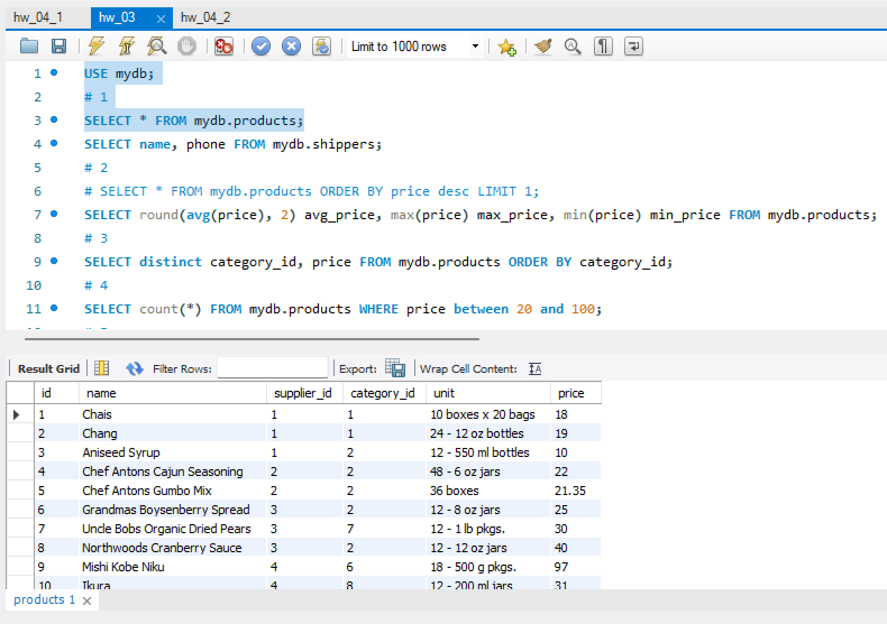

SELECT name, phone FROM mydb.shippers;
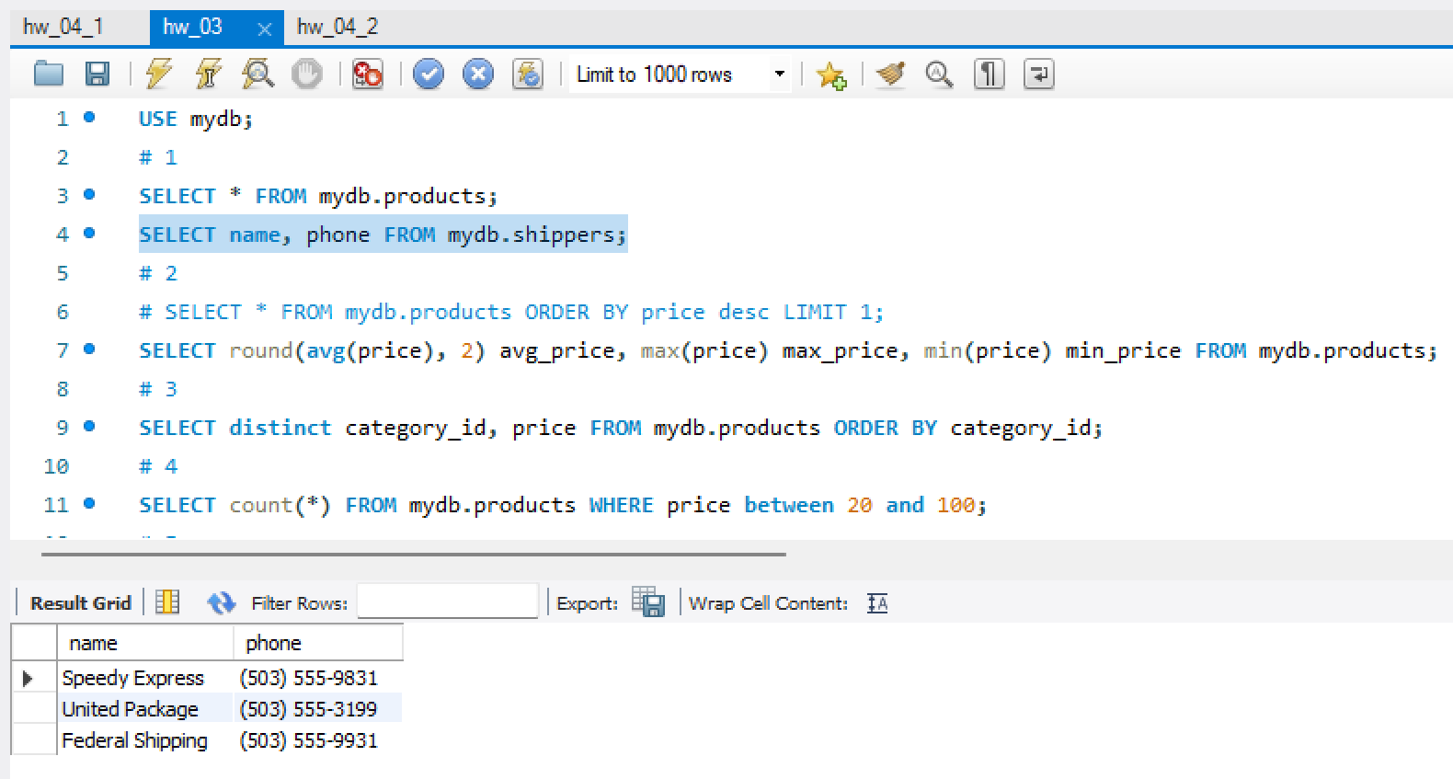

# 2
SELECT round(avg(price), 2) avg_price, max(price) max_price, min(price) min_price FROM mydb.products;
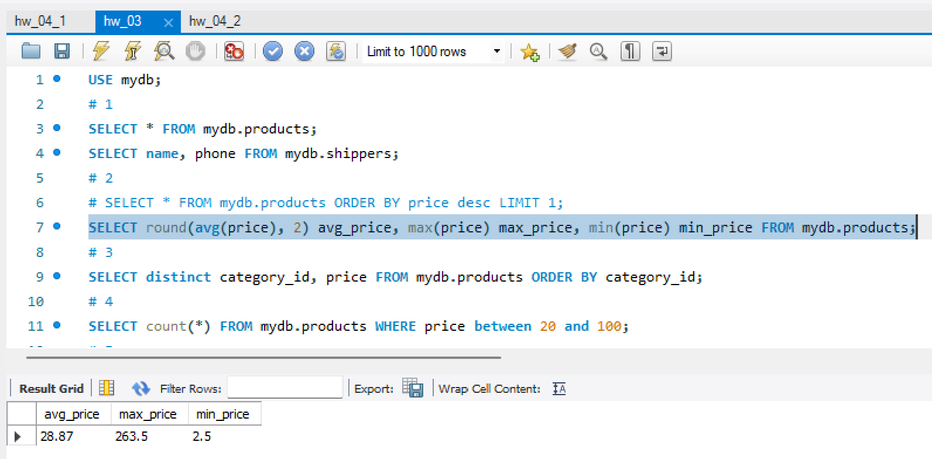
# 3
SELECT distinct category_id, price FROM mydb.products ORDER BY category_id;
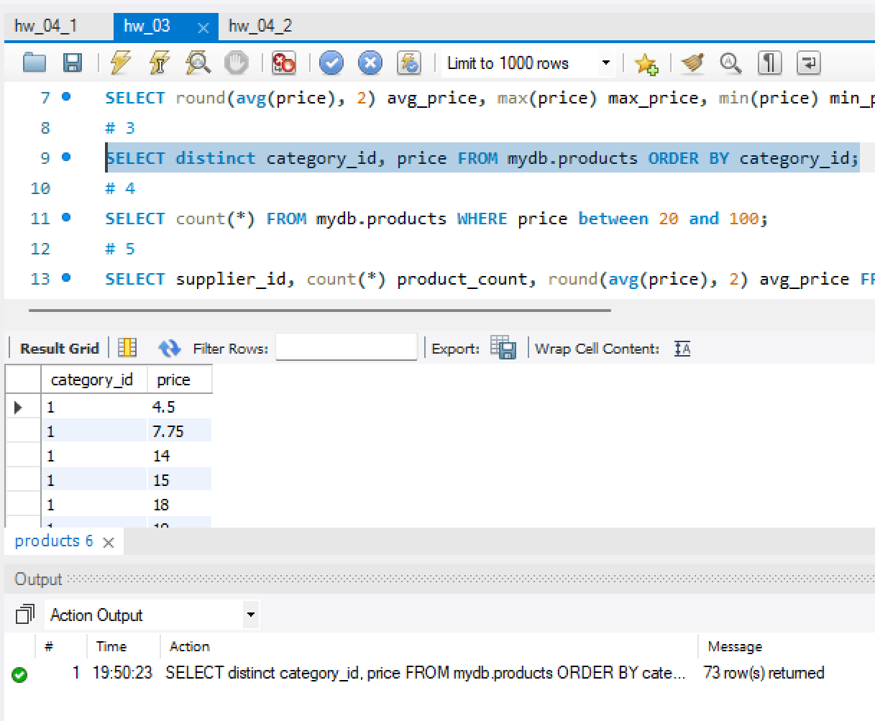
# 4
SELECT count(*) FROM mydb.products WHERE price between 20 and 100;
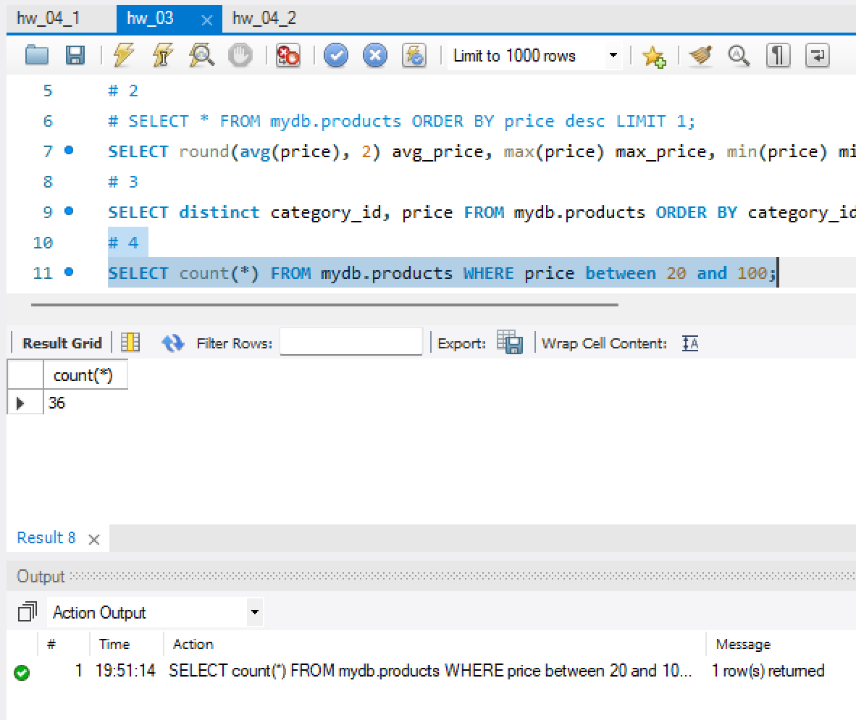
# 5
SELECT supplier_id, count(*) product_count, round(avg(price), 2) avg_price FROM mydb.products GROUP BY supplier_id;
